Milestone 7: RAG Pipeline Implementation – Gradient Descenters
Retrieval Augmented Generation for Database Agent Application
The RAG pipeline in our application is setup to enhance the SQL Query generation from user provided natural language. The relevant context we are including in our RAG setup include SQL Query examples that have been validated, join patterns, table schemas, along with business rules we want our agent to adhere to.
Our intended result is to use this to provide focused, query-specific context that will improve the SQL generation accuracy, while decreasing result latency and token usage.
Document Selection, Vector Database, Embeddings, and Chunking
64 documents were stored into a ChromaDB vector database. Some of this content was created using a data dictionary for the AdventureWorks2025DW database found online. Our documents include
- 22 validated SQL Examples
  - These serve as the gold-standard query answer pairs, and they provide few-shot learning examples for the LLM to use
- 7 Join patterns
  - Table relationship templates which will prevent join errors and provide context. Used to encode complex dimensional modeling relationships between fact and dimension tables.
- 14 Table Schemas
  - Column definitions and data types, enabling accurate column selection and filtering. Selected the relevant Fact (4) and Dimension tables (10)
- 21 Business Rules
  - These provide metric definitions and constraints as learned from the data dictionary. They ensure compliance with business logic and privacy rules.
OpenAI “text-embedding-3-small” was chosen for our embedding model, as it produces dense vector representations that capture query intent.
We chose ChromaDB as our vector database since it has a collection-based organization for our 4 collections (examples, join patterns, schemas, and business rules).
For our chunking strategy, we did this at the document level as described in the 64 documents above. Each SQL example, table schema, and join is its own document. Business rules are stored within one document.

Retrieval Mechanisms
Retrieval was done using K-Nearest-Neighbors with cosine similarity. The retrieval was set to extract the Top-K from each of our collections. K_examples = 3 (for the most similar SQL examples), k_patterns = 2 (For the most relevant join patterns), k_schemas = 5, and so on.
This selective retrieval is more useful than the previous baseline approach we had of providing all 31 database tables to the agent every time. This will help reduce noise to the LLM, help it identify the correct tables faster, decrease token consumption, and minimize hallucinations.
For similarity scoring, each retrieved document includes a distance metric, where the lower they are the more similar and a similarity score which the higher it is, the more relevant.
Context Integration for Response Quality
The RAG enhanced prompt retrieved the most relevant SQL examples, most relevant join patterns, most relevant table schemas, and all of the business rules. This is more dynamic and context driven compared to the baseline prompt we were using before implementing the RAG pipeline.
Evaluation & Metrics
We found that of the 12 test cases we evaluated retrieval quality for (moderate complexity), the result
- Precision@5 = 1.0
- Recall = 0.889
- F1 Score = 0.928
- Perfect Retrievals = 9/12
We found from accuracy standpoint, the RAG system slightly outperformed our baseline model (12/15 successful queries compared to 11/15). The failed queries were ones that were very complex involving window functions.
The real area where the RAG pipeline shined was in latency and token usage. We saw a decrease in token usage by 77%, and average latency reduction of 29%, both which are significant improvements when considering that a database agent would be used by many individuals in a sales organization. Implementing the RAG pipeline would significantly reduce cost and improve performance.

Appendix:
RAG Documentation
SQL Examples. 1 of 22 SQL examples
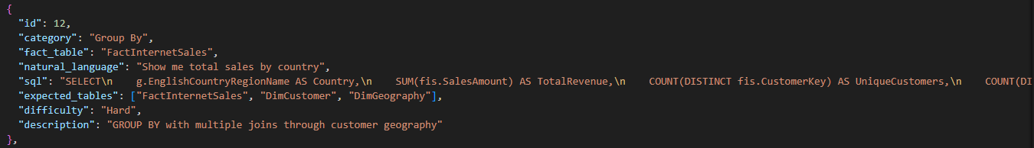

Business Rules (metric definitions, privacy, customer segmentation, product classifications, time periods, geography, and naming convention rules). Screenshot is just a small portion of this
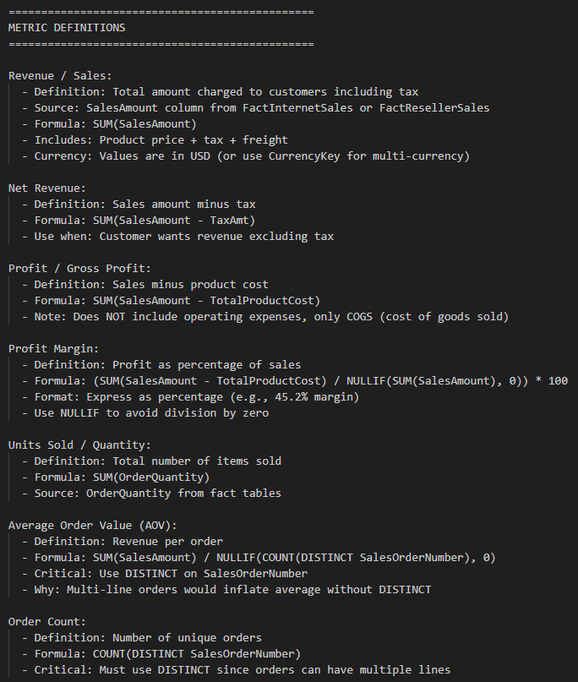
Glossary of terms used in database (just a section of a total glossary taken from data dictionary)
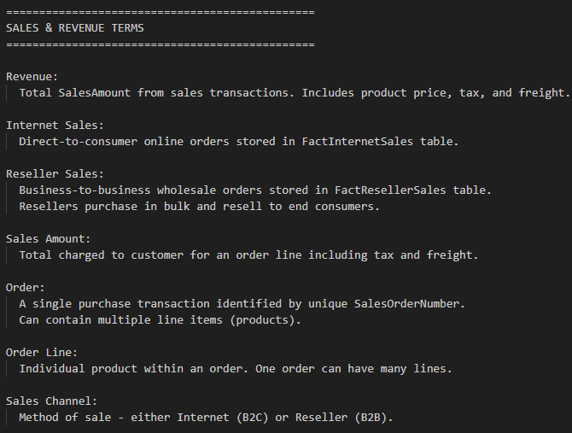
Join patterns (1 section of 1 join pattern, 7 total)
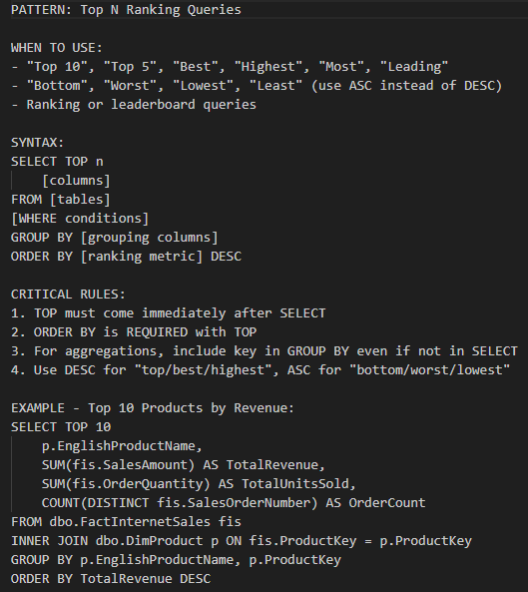
Schema (1 section of 1 schema, 14 total). Taken from Data Dictionary
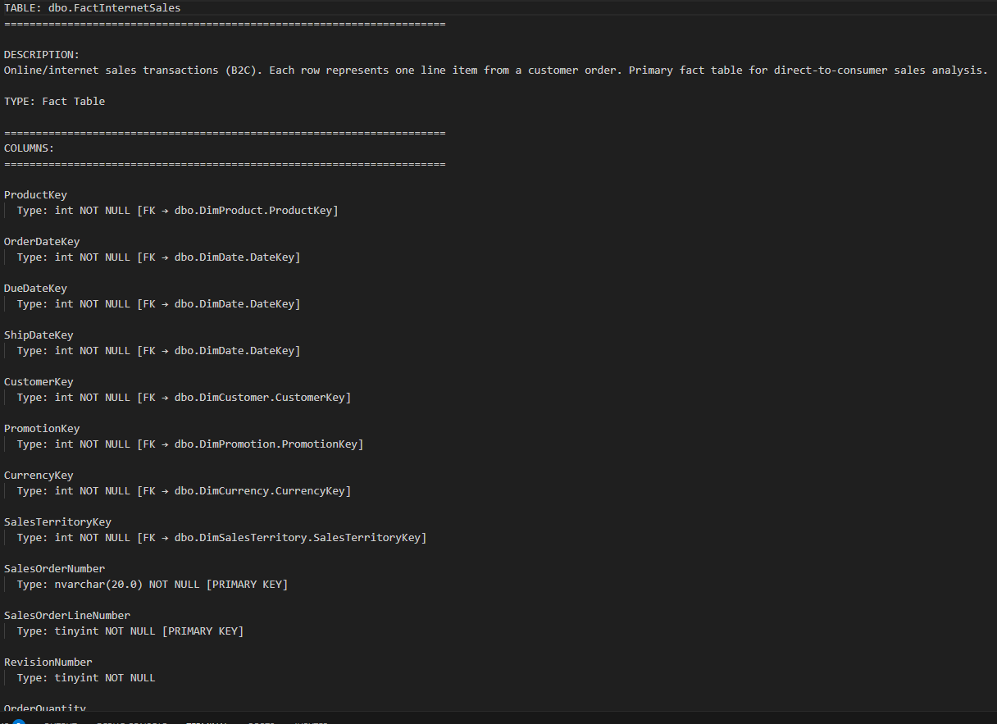
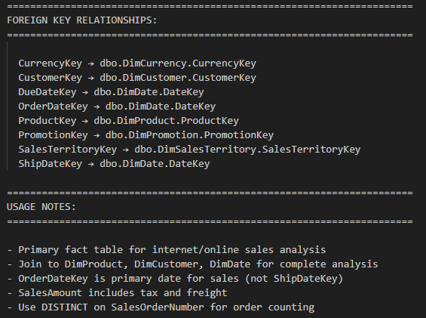
Vector Database Loading
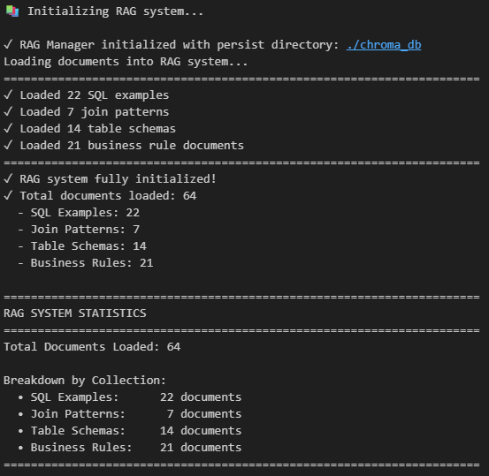
Retrieval
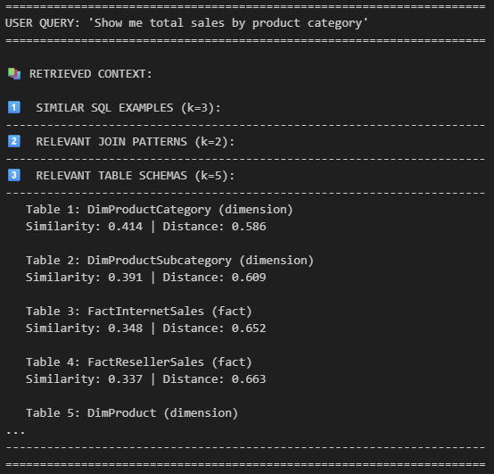
SQL generation with RAG
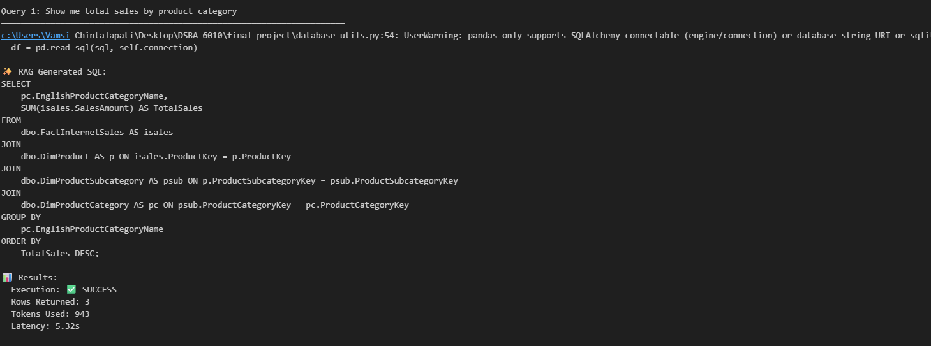
Evaluation
